#include <iostream>
using namespace std;

int main() {
int a, b, c;

// Ask the user to input three integer values
cout << "Enter three integer values: ";
cin >> a >> b >> c;

// Dynamically allocate memory for each integer and initialize it
int* ptrA = new int(a);
int* ptrB = new int(b);
int* ptrC = new int(c);

// Display the values and the memory addresses stored in the pointers
cout << "Value of a: " << a << ", Address in ptrA: " << ptrA << ", Value pointed by ptrA: " << *ptrA << endl;
cout << "Value of b: " << b << ", Address in ptrB: " << ptrB << ", Value pointed by ptrB: " << *ptrB << endl;
cout << "Value of c: " << c << ", Address in ptrC: " << ptrC << ", Value pointed by ptrC: " << *ptrC << endl;

// Free the dynamically allocated memory
delete ptrA;
delete ptrB;
delete ptrC;

return 0;
}

BEGIN
// Step 1: Get user input for three integers
PRINT "Enter three integer values: "
READ a, b, c

// Step 2: Dynamically allocate memory for each integer
ptrA ← NEW integer initialized with value a
ptrB ← NEW integer initialized with value b
ptrC ← NEW integer initialized with value c

// Step 3: Display the variable values, pointer addresses, and values at those addresses
PRINT "Value of a: ", a, ", Address in ptrA: ", ptrA, ", Value pointed by ptrA: ", VALUE_AT(ptrA)
PRINT "Value of b: ", b, ", Address in ptrB: ", ptrB, ", Value pointed by ptrB: ", VALUE_AT(ptrB)
PRINT "Value of c: ", c, ", Address in ptrC: ", ptrC, ", Value pointed by ptrC: ", VALUE_AT(ptrC)

// Step 4: Deallocate the dynamically allocated memory
DELETE ptrA
DELETE ptrB
DELETE ptrC
END

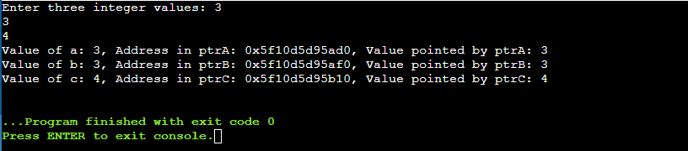

https://github.com/uhlarmd/CSC450-M3

